For Immediate Release:
December 15, 2014
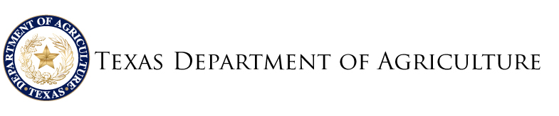
TEXAS DEPARTMENT OF AGRICULTURE HONORS MYLES MARTINEZ OF JAMES EARL RUDDER HIGH SCHOOL WITH ‘GROW’ AWARD
Award Gives Recognition for Outstanding Work completed by middle and high school students

AUSTIN – The Texas Department of Agriculture (TDA) today honored Myles Martinez, a junior from James Earl Rudder High School in Bryan, Texas, as the winner of the Texas Department of Agriculture’s monthly GROW award. The award Gives Recognition for Outstanding Work to middle and high school students who demonstrate leadership and excellence inside and outside the classroom.
“It is a privilege to recognize great Texas students like Myles with the GROW award,” Deputy Commissioner Drew DeBerry said. “Myles is one of the many young Texas leaders who will help the Lone Star State continue to thrive and reach even more prosperous heights. The future of Texas is bright because of talented, driven and hardworking students like Myles.”

Myles was chosen from a talented pool of Texas students for demonstrating leadership in his school activities, as well as his commitment to community service. Myles is currently serving as secretary of the Rudder FFA chapter. He also is a member of the Brazos County 4-H Sportsman Club, as well as the National Honor Society. Every year, Myles has been recognized as a ‘Student of the Month’ at his high school.

“Myles exemplifies good character and leadership skills naturally,” said Larry White, agriculture science teacher and FFA advisor at James Earl Rudder High School. “Every task assigned to him is completed quickly, completely and with a smile. It has been a pleasure to see Myles grow and learn as much as he can about agriculture and the potential he has to pursue this as a career in the future.”

Furthermore, Myles works hard raising commercial and show cattle. He also competes in numerous competitions representing FFA and 4H, where his list of awards is pretty impressive. Myles won first place and a $10,000 scholarship at the San Antonio Livestock Show for his ag science fair project. He also placed third in the state with this same project at the FFA convention. Myles has received the Star Farmer Award in FFA; won the Reserve Grand Champion at the State Fair of Texas Youth Agri-Science Fair, Agricultural/Mechanical Engineering Science Division; and won first place in the commercial heifer senior division at the 2014 Brazos Valley Fair.

Despite any challenges thrown his way, Myles shows leadership in everything he does at school and sets a positive example for his peers by making good grades in class. He has excelled in his agriculture classes, and he tackles challenging academic courses with rigor.

Additionally, Myles gives back to his community and peers. He is always willing to help with service projects for his community and his school. He also gives back to his fellow classmates by helping younger students with their ag science fair projects. Myles’ teachers know he is willing to go the extra mile to serve his school and community.

“I greatly appreciate this recognition from the Texas Department of Agriculture,” said Myles. “It just goes to show that the things you do now will affect you in the future.”

Myles hopes to attend Texas A&M University and major in agriculture. He also hopes continue raising cattle with his family

